**Mini Lab Test (48 Points)**

# Q1: CSS and Bootstrap (10 Points)

Assume that you would like to build a Web page showing an inspirational quote displayed over a nice image.

**PART A:** In this first design, you would like to apply your CSS knowledge to have the page as shown below.

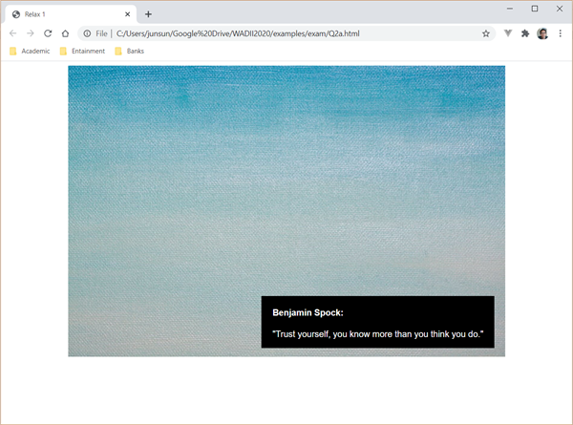

Complete Q1a.html so that the following requirements are satisfied (Do NOT change the HTML code)

The following are the specific requirements.

● The image should be displayed with a width of 800px;

● The image should be shown in the center of the window.

● The block of text is shown at the bottom-right corner of the image.

● The text is in white over a black background.

● The right edge of the text block is 20px from the right edge of the image and the bottom edge of the text block is 20px from the bottom edge of the image.

● There are paddings of 20px on the left and right of the text block.

**PART B**: In this second design, you would like to apply Bootstrap to make the page more responsive using the help of Bootstrap classes such as “row”, “col-*” and “Card” (Bootstrap component) . The design is shown below.

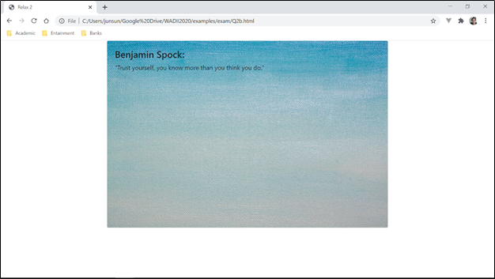

The image and text will be presented in the form of a *card* in bootstrap.

Furthermore, the card should be shown in the center, occupying 5/6 of the width of the browser window. The remaining width will be distributed equally on the left and right. Note that the size of the image should change accordingly when the browser is resized.

Complete Q1b.html to achieve the effect using only **Bootstrap** classes.

# 

# Q2: Bootstrap & CSS (10 Points)

**PART A:** Q2a.html is an HTML file adapted from [Bootstrap Album](https://getbootstrap.com/docs/5.1/examples/album).

Edit Q2a.html as little as possible in order to achieve the following objectives. All changes are to be made in the same HTML file.

Here is what you need to achieve (see screenshot below):

1. Insert a red color third button labelled “3rd call to action” beside the two original buttons.
2. Edit the background color of the thumbnail section to orange.
3. Currently, 1, 2 or 3 thumbnails appear in each row depending on the browser’s width. Edit the HTML file such that when the browser width is wide enough, the user should see 4 cards in each row.

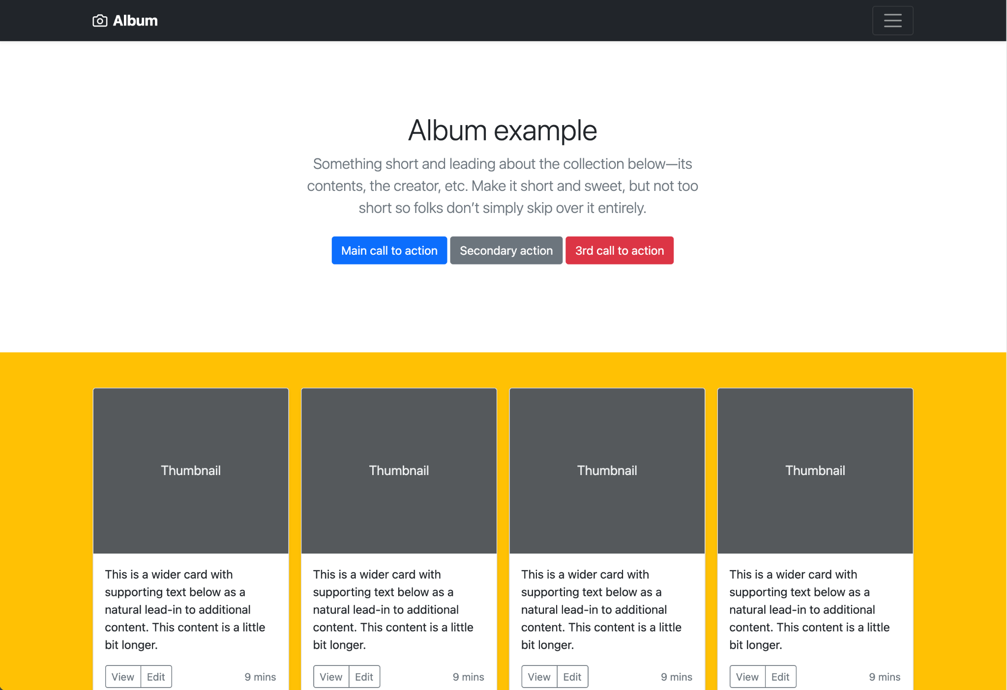

**PART B:** Open Q2b.html in a browser. This is how it looks:

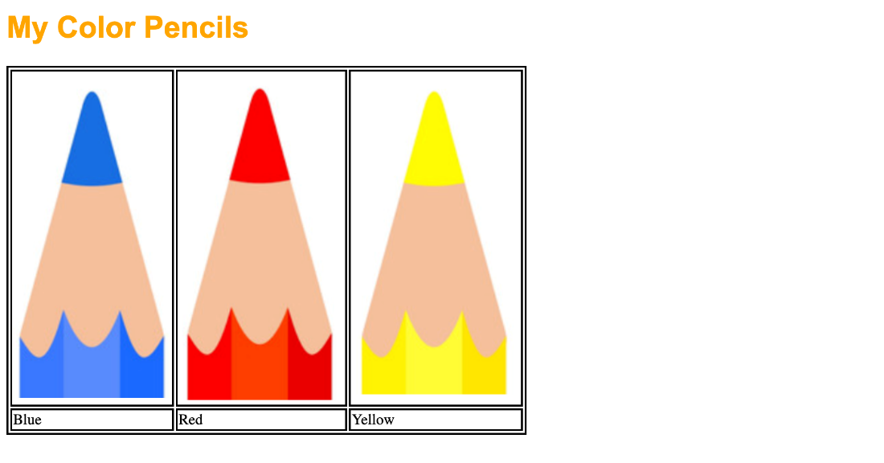

Edit only the <STYLE> element in the HTML file so that it looks like this:

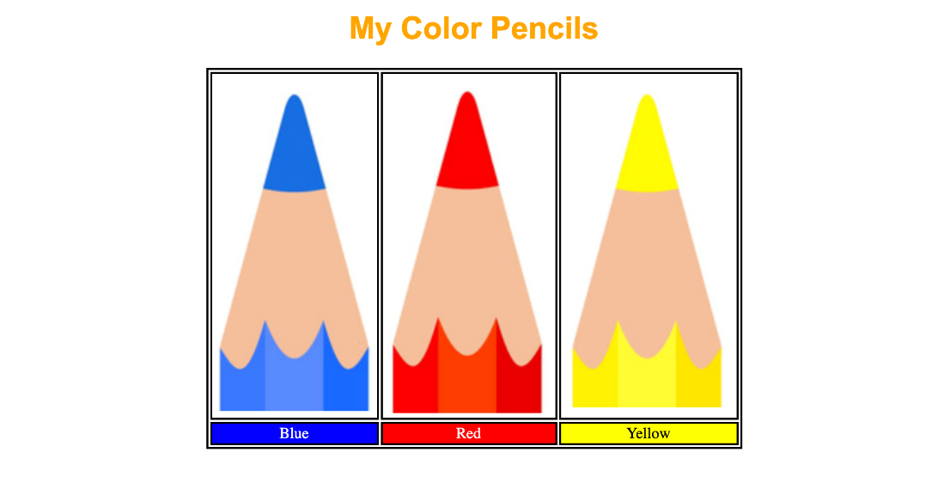

The heading "My Color Pencils" and table are to be centered in the browser window. Pay attention to the text colors as well as the background color of the second row in the table. “My Color Pencils” is supposed to be in orange. Do not link to any external file and only the STYLE element can be edited.

# 

# Q3: Javascript and CSS (10 Points)

Q3.html is a fully functional HTML file from getcodingkids.com.

Do not break the current functionality of the game and edit Q3.html as little as possible in order to achieve the following objectives. All changes are to be made in the same HTML file, and the HTML file should not link to any external resources.

Here is what you need to achieve:

1. The whole grid of 9 cells has a background color of "lightyellow" when the page is loaded.

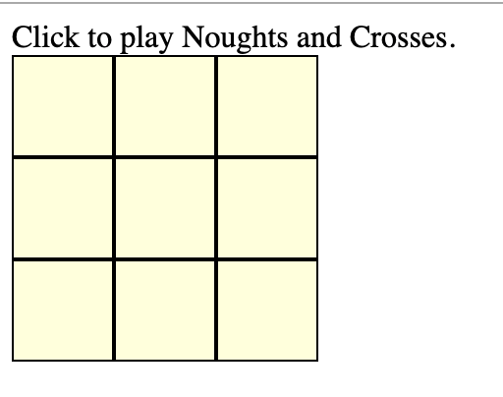

1. The Xs and Os should be horizontally aligned center when they appear within each cell. They don’t have to be vertically aligned though.
2. For now, the game always starts with O as the first player. Change it so that when the page loads, it prompts for "Who starts first? (X or O)" and use the response to determine the first player. If the user enters an invalid response to the prompt, there is no need to show an error message, and the game should just default to O as the starting player.

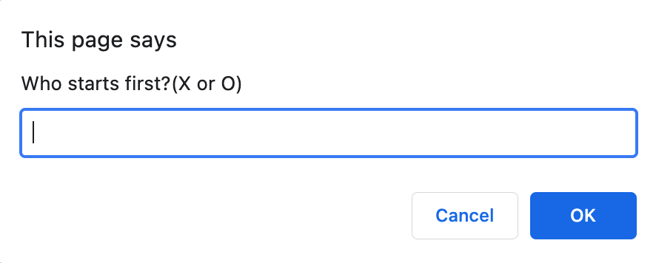

1. When they appear in the grid, all Xs should be blue and Os should be red. If you are unable to do this, make both X and O red in color.

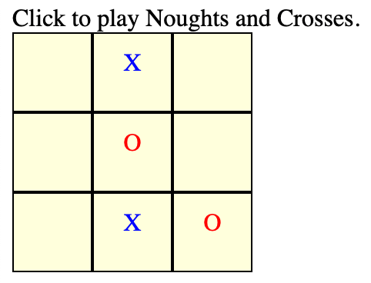

1. When someone wins, the alert message should show "Winner is X" or "Winner is O", instead of just "Winner!".

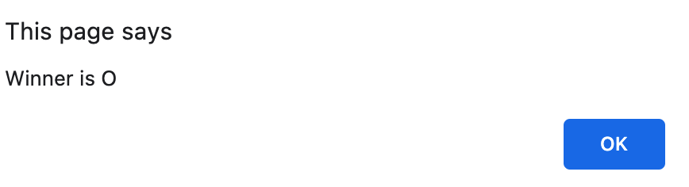

# 

Q4: Javascript and DOM (10 Points)

You are to build a menu ordering page as shown in the following two figures. It shows an Ala Carte menu as well as a set menu. At the top of the page, when nothing is selected, it shows “You haven’t ordered anything”; otherwise, it shows the ordered items together with the price of each ordered item as well as the total price, as shown in the Figures.

|  |
| --- |
|  |

Q4.html shows the skeleton of the page. Complete the page at the position indicated by the **“TODO”** comments. Do not change any other given code.

Note that the prices of the items are a part of the page. You are to read the price from the page. Furthermore, the function updt(order) is invoked whenever the user selects or un-selects an item. Define the function so that the selected items are shown at the top of the page.

|  |
| --- |
|  |

Note that to update the message at the top of the page, you are allowed to set .innerHTML for this exercise.

# Q5: Asynchronous Request and Javascript (8 Points)

We would like to build a Web page which changes its appearance according to the time the user loads the page, i.e. the page will have a black background if it is loaded half an hour before sunrise or half an hour after sunset; and will have a particular background during dawn (half an hour before and after sunrise, both inclusive) and twilight (half an hour before and after sunset, both inclusive); and will have a white background otherwise. Four CSS classes have been defined in Q5.html. Your task is to associate the right CSS class with the tag body depending on when the page is loaded.

To know the exact sunrise and sunset time, we would like to use the Web service provided by openweathermap.org. The following shows a sample JSON response from the Web service

{

"coord": {

"lon": 103.85,

"lat": 1.29

},

"weather": [

{

"id": 803,

"main": "Clouds",

"description": "broken clouds",

"icon": "04d"

}

],

"base": "stations",

"main": {

"temp": 303.76,

"feels_like": 307,

"temp_min": 303.15,

"temp_max": 304.15,

"pressure": 1009,

"humidity": 70

},

"visibility": 10000,

"wind": {

"speed": 4.1,

"deg": 180

},

"clouds": {

"all": 75

},

"dt": 1600402268,

"sys": {

"type": 1,

"id": 9470,

"country": "SG",

"sunrise": 1600383320,

"sunset": 1600426938

},

"timezone": 28800,

"id": 1880252,

"name": "Singapore",

"cod": 200

}

The data contains the sunrise and sunset time, in the UNIX time format, i.e., the number of **seconds** since the UNIX Epoch (00:00:00 UTC on 1 January 1970). Write a function handleData which takes the JSON data, reads the sunrise and sunset time and updates the appearance of the page accordingly using the given CSS classes.

## Hint: You can use new Date().getTime() to get the number of milliseconds since the [Unix Epoch](https://en.wikipedia.org/wiki/Unix_time).